## Q-1: ProblemStatement:

Create a registration form for XYZ University. The form should look as shown in the image below.

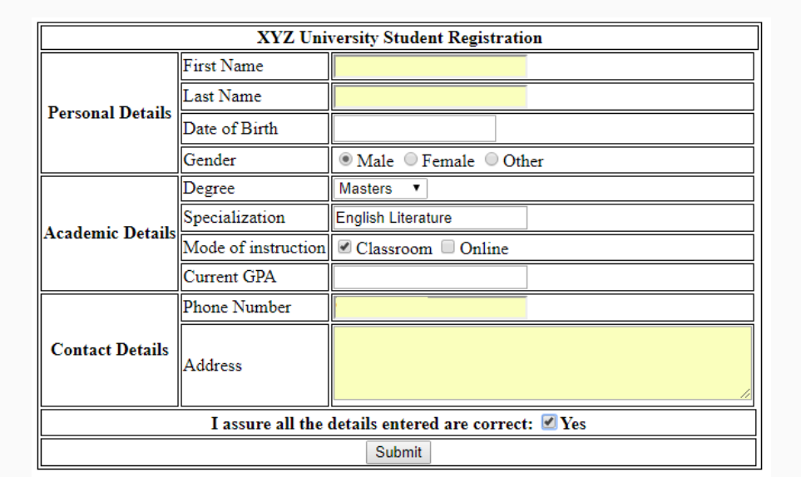

The validations for each field are described below:

* **First Name**: Required, max 10 characters
* **Last Name**: Required, max 10 characters
* **Date of birth**: Required
* **Gender**: Only one option must be selected
* **Degree**: Dropdown should contain "Bachelors", "Masters" and "Doctorate"
* **Specialization**: Required, max 40 characters
* **Current GPA**: Required, max value 5, increment in steps of 0.1
* **Phone Number**: Required
* **Address**: Required, max 4 rows of 40 characters each.

**All required fields should be marked with a red asterisk (*)**

## Q-2: ProblemStatement:

Create the below table for Destiny Tours & Travels price list.

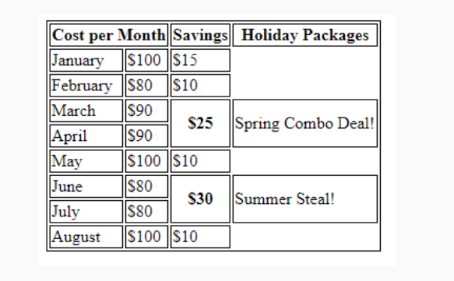

Q-3: 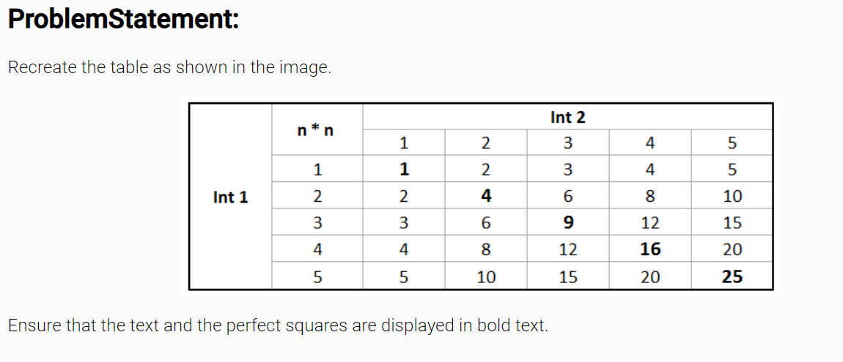

## Q-4: ProblemStatement:

Create a form for XYZ online pizza delivery service as shown in the image below.The validations for each field are given below:

* **First Name:**Required, max 20 characters
* **Phone Number**: Required
* **Size**: Required, only one option can be selected
* **Base**: Required, Dropdown should contain "Pan Pizza", "Cheese Crust" and "Chicken Stuffed Crust"
* **Additional details**: contains 2 rows of 30 cols each.

All required fields must be marked with a red asterisk (*)

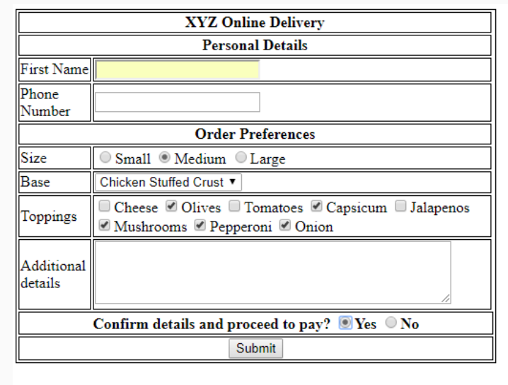

Q-5:PROBLEM STATEMENT – Create the below Form using HTML5 and CSS

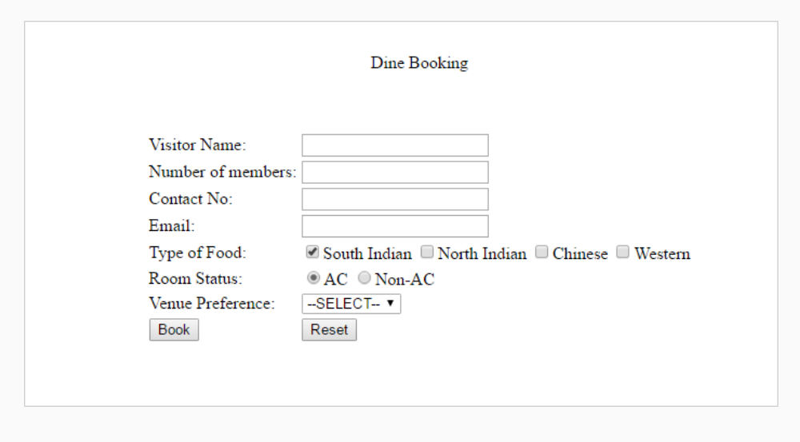

## Q-6: ProblemStatement:

– Create the below layout using Flexbox and Media Query. Depending upon the screen size defined you need to apply the media rules.

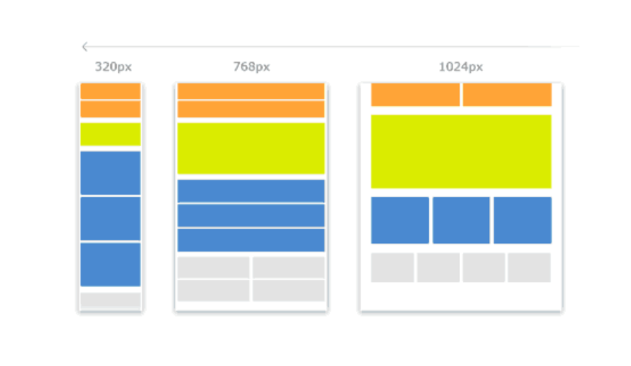

## Q-7: ProblemStatement:

Create the below page using **HTML5 semantic element and CSS3 Flexbox with SASS.**

Note: It should look similar to the page below.

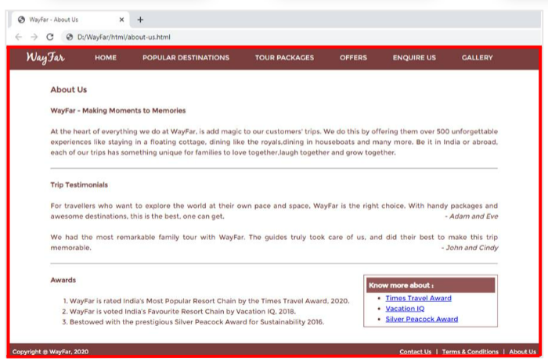

## Q-8: ProblemStatement:

Create the Contact Us page as shown below. Use HTML5,CSS3,SASS.Define SASS variables, function , mixins, nesting to create the page.

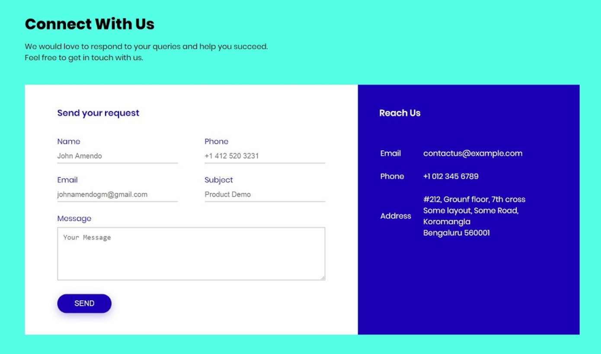

## Q-9: ProblemStatement: Create this page with these 3 cards using HTML5 and CSS3,SCSS,Box Model,CSS3 Selectors.



## Q-10: ProblemStatement: Create this page using HTML5 Semantic Elements and CSS3 Flexbox, Layout, Compositors, SASS,Gradient.

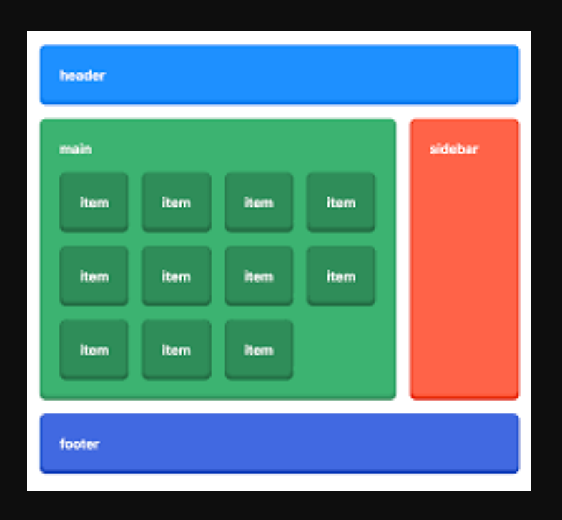

## Q-11: ProblemStatement:

**1. home.html**

This page renders the information about the company. It has a ‘Explore More’ button when clicked should take the user to services.html**. Here : Use Html5 Semantic Elements,CSS3 Selectors, Flexible Layout, Flexible images. Use SASS (CSS Preprocessor)**

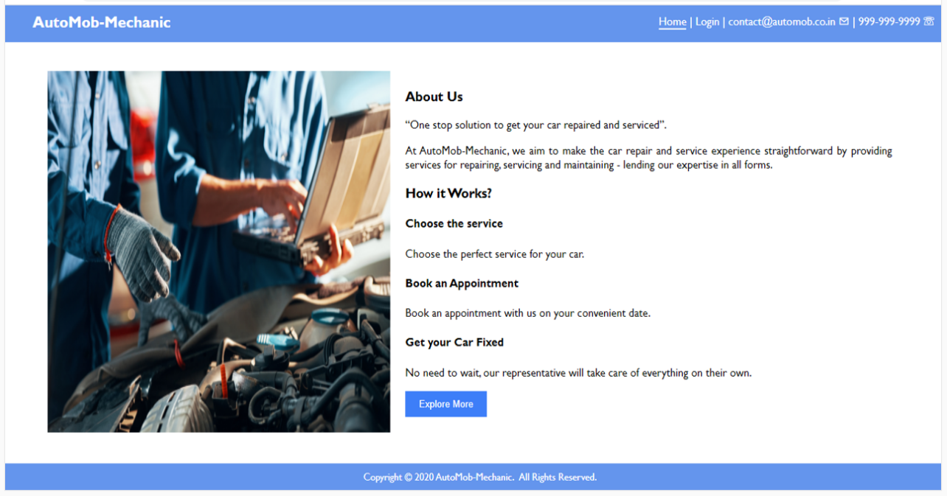

**Hint: onclick event, location.assign()**

2.Services.html : Here you have to display the content as it is. In bottom you have to use a timer to display **Offers ends in. To display those services use a javascript array to read the data.

**Note: Use setInterval() in Javascript**

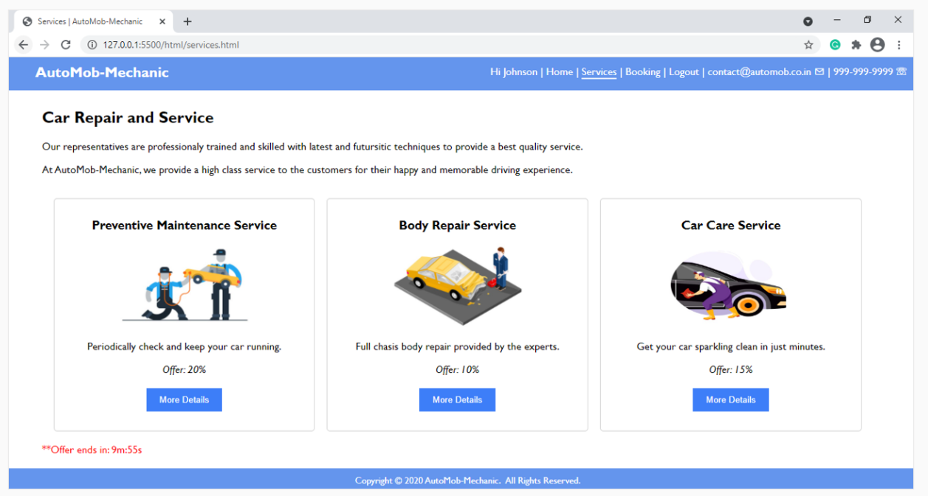

3. Reports.html – This page will render a table . Here you have to read the data from a javascript array.

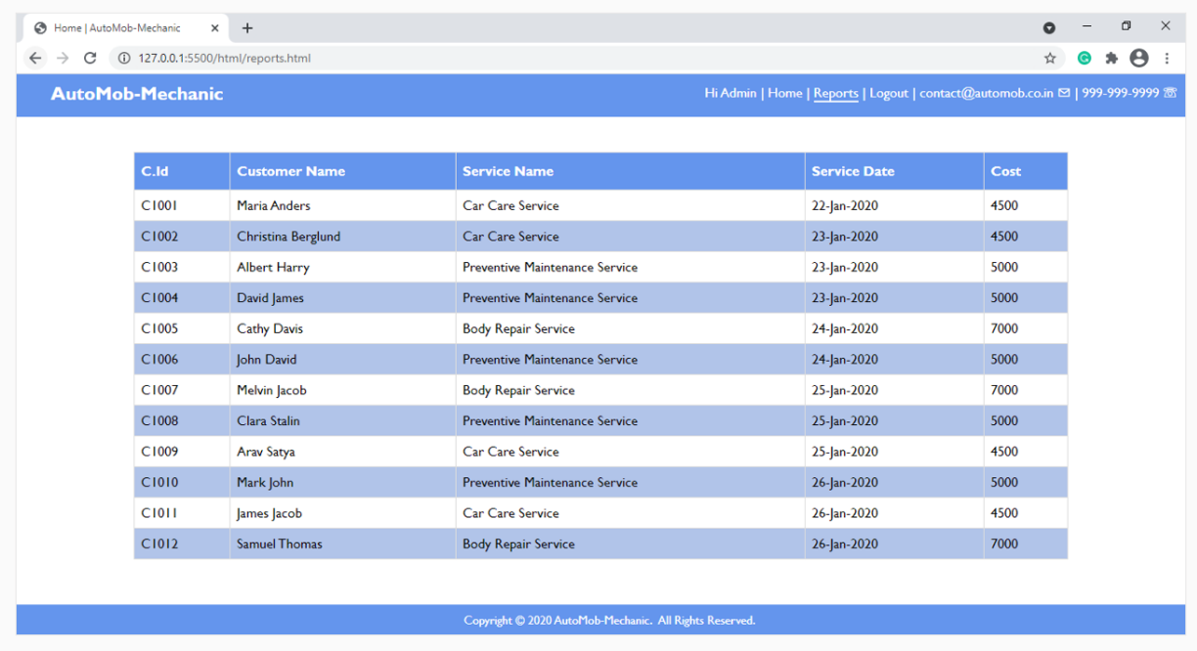

12. Create the table using Delete functionality. **Note: Use JavaScript Array Method and DOM API to implement this, Apply transition effect while deleting .**



13. Create an UI with **HTML5,CSS3,SASS and Add functionality using JavaScript. Here use JavaScript Array of Objects and array functions.**

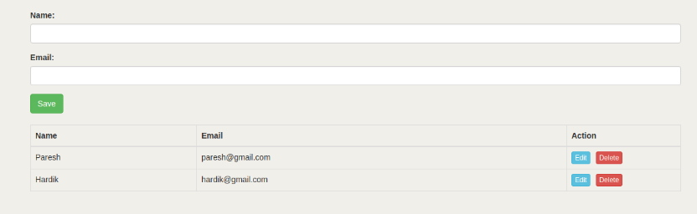

If you click on delete button then the row should deleted from the table. Using Edit button we can update the respective row.

14. Create the calculator using **Html5,Css3 and JavaScript Math API**.

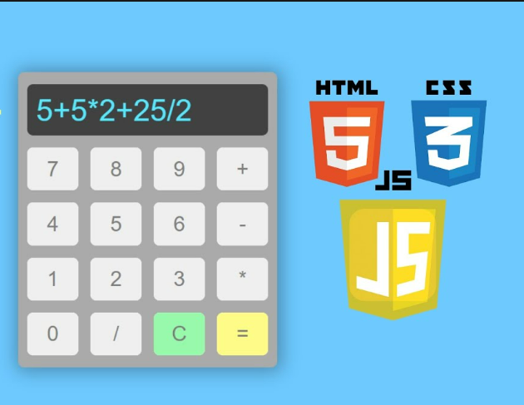

15.Create your own **code pen Using HTML5,CSS3,JavaScript.Note:Here Make the div editable.(contenteditable=true)**

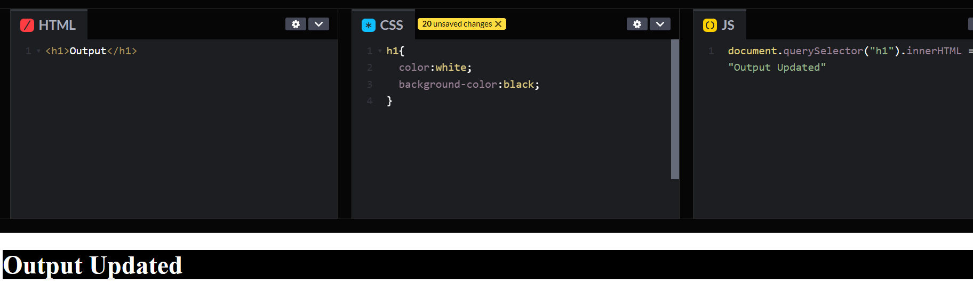

Here three sections are there. 1.HTML,2.CSS3.JavaScript

Then the output will display in the output section.

16. Create a **image slider using CSS3 Animation** . Here define an array of 10 images and use transition effect to automatically change the images in the slider.



17. Create a Age Calculator . After entering Date Of Birth, if you click on Calculate button it will display the age. And here you can select a specific date to calculate the age on that specific date. **Note : Use JavaScript Date object.**

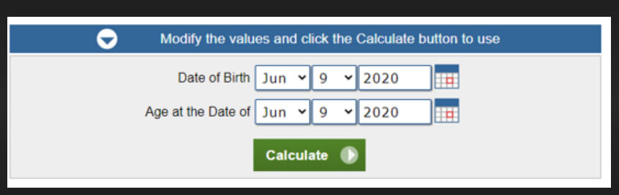

18. You have to create a console application on Hospital Simulator using JavaScript

## Problem Statement

You were asked by a doctor friend to prepare for her a "Hospital simulator", which can simulate the future patients’

state, based on their current state, and a list of drugs they take.

Patients can have one of these states:

* `F`: Fever

* `H`: Healthy

* `D`: Diabetes

* `T`: Tuberculosis

* `X`: Dead

In the "Hospital Simulator" drugs are provided to **ALL** patients. It is not possible to target a specific patient.

This is the list of available drugs:

* `As`: Aspirin

* `An`: Antibiotic

* `I`: Insulin

* `P`: Paracetamol

Drugs can change patients’ states. They can cure, cause side effects or even kill a patient if not properly prescribed.

Drugs effects are described by the following rules:

* `Aspirin` cures `Fever`;

* `Antibiotic` cures `Tuberculosis`;

* `Insulin` prevents `Diabetic` subject from dying, does not cure `Diabetes`;

* If `Insulin` is mixed with `Antibiotic`, healthy people catch `Fever`;

* `Paracetamol` cures `Fever`;

* `Paracetamol` kills subject if mixed with `Aspirin`;

* One time in a million the `Flying Flying Spaghetti Monster` shows his noodly power and resurrects a dead patient

( `Dead` becomes `Healthy`).

## Simulation

### Input

#### Parameter 1

List of patients' health status codes, separated by a comma. e.g. `D,F,F` means we have 3 patients, one with `Diabetes`

and two with `Fever`.

#### Parameter 2

List of drugs codes, separated by a comma, e.g. `As,I` means patients will be treated with `Aspirin` and `Insulin`.

### Output

The result should be sent to stdout. It should be a comma separated string with number of patients with a given state,

following the format:

```text

F:NP,H:NP,D:NP,T:NP,X:NP

```

Where:

* `F`, `H`, `D`, `T`, `X` are patients’ health status codes;

* `NP` is a number of patients for a given state;

E.g. `F:0,H:2,D:0,T:0,X:1` means there are two healthy patients and one that is dead.

### Examples

1. ```bash

$ ./hospital-simulator D,D

$ F:0,H:0,D:0,T:0,X:2

```

* Input: `D,D `

* Output: `F:0,H:0,D:0,T:0,X:2` (Diabetic patients die without Insulin)

2. ```bash

$ ./hospital-simulator F P

$ F:0,H:1,D:0,T:0,X:0

```

* Input: `F P`

* Output: `F:0,H:1,D:0,T:0,X:0` (paracetamol cures fever)

19. Create an **online exam system using JavaScript,Html5,Css3.**

Screen-1:



Screen-2:

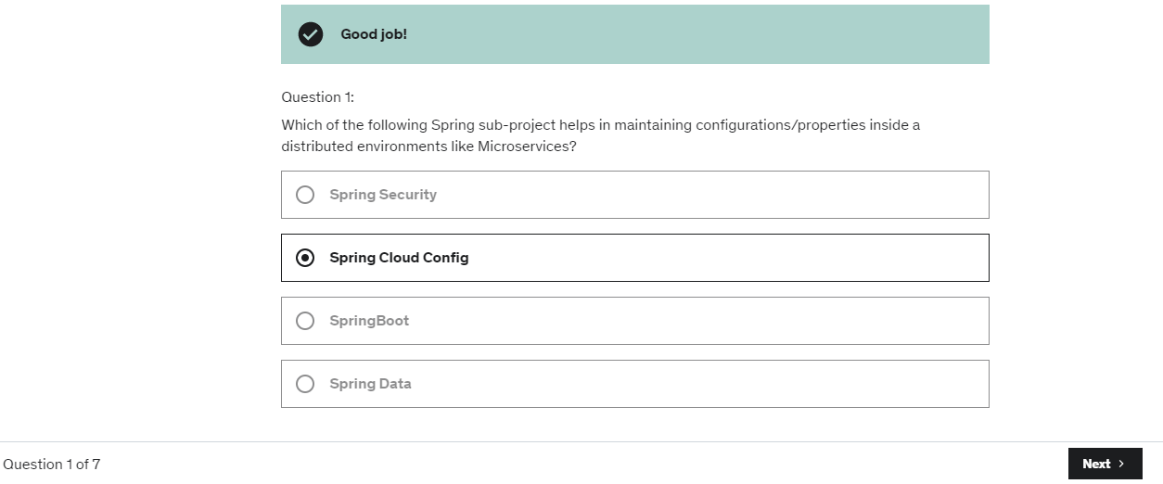

Screen-3:

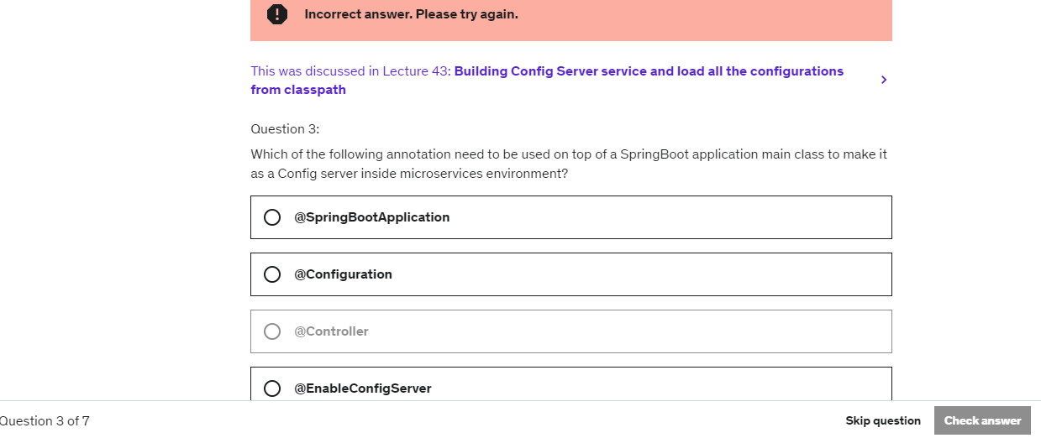

Screen-4:

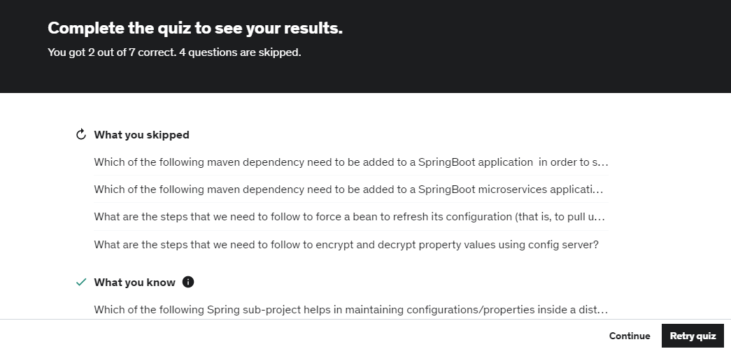

**Note: Use JavaScript object array to save all the questions, options, right option . Once exam completed , you have to show the last screen with 3 sections.**

**1st section – The questions that user has skipped**

**2nd section – The questions user answered correctly**

**3rd section – the questions user answered wrongly**

20. Create Search functionality as below. Here use **fetch API** using JavaScript to fetch the country details.

Here there are 3 json files are provided to work with the functionality.

**Note :Use promise or async and await to implement this.**

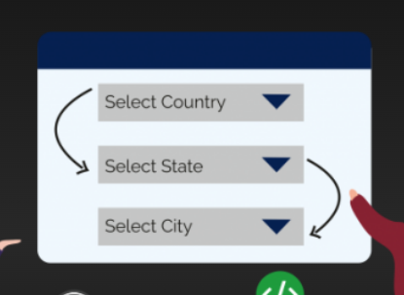

21. Here we have to create a web page where we can add element to an array , remove element from an array, Remove all element from an array. **Use Array methods like push(),pop(),shift(),unshift()** . To display all the elements use array function like **forEach**. Add **two more buttons in this form so that we can display all the fruit name in either captal letter or small letter by clicking on the respective buttons**. Use **map()** function of an array and other string functions.

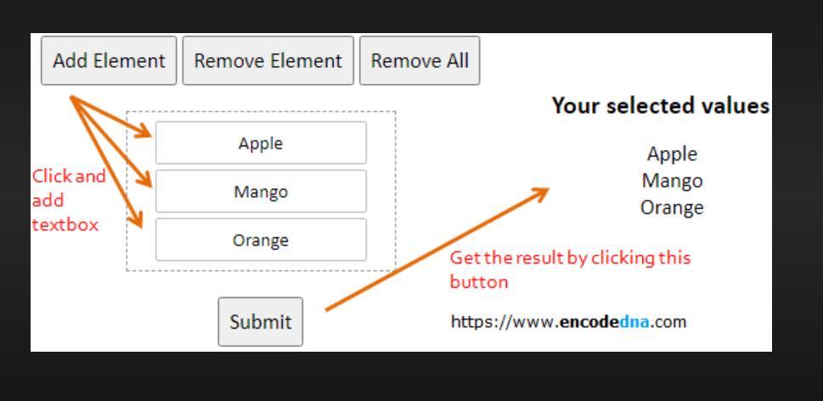

22. Here we have to create an Employee Information System.

In this form

* We can add a new employee to an array by adding all the details.
* We can delete a specific employee from the employee Array whose details are shown.
* We can Update the details of an employee.
* We can search an employee by id,by telephone number.
* We can move in the array using those buttons moveFirst,moveLast,moveNext,movePrevious.

**Note: Define an Array that will contain all the employee object.Define ES6 Arrow function to perform these functionalities.Use Javascript array functions like concat, every, filter, find, forEach, from, indexof, join, lastIndexOf, map, of, pop, push,reverse, shift, slice, some, sort, splice, unshift.**

**Note: No need to implement About and Quit.**

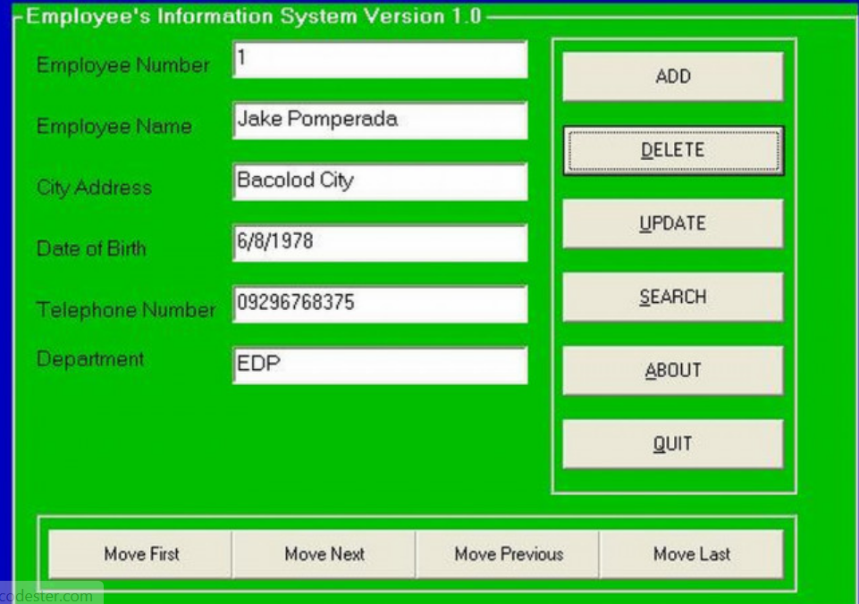

23. Write a JavaScript function to get the first element of an array. Passing a parameter 'n' will return the first 'n' elements of the array.    
*Test Data*:  
console.log(first([7, 9, 0, -2]));  
console.log(first([],3));  
console.log(first([7, 9, 0, -2],3));  
console.log(first([7, 9, 0, -2],6));  
console.log(first([7, 9, 0, -2],-3));  
Expected Output :  
7  
[]  
[7, 9, 0]  
[7, 9, 0, -2]  
[]

24. Write a JavaScript function to get the last element of an array. Passing a parameter 'n' will return the last 'n' elements of the array.    
*Test Data*:  
console.log(last([7, 9, 0, -2]));  
console.log(last([7, 9, 0, -2],3));  
console.log(last([7, 9, 0, -2],6));  
Expected Output :  
-2  
[9, 0, -2]  
[7, 9, 0, -2]

25. Write a simple JavaScript program to join all elements of the following array into a string.    
*Sample array*: myColor = ["Red", "Green", "White", "Black"];  
Expected Output :  
"Red,Green,White,Black"  
"Red,Green,White,Black"  
"Red+Green+White+Black"

26. Write a JavaScript program to sort the items of an array.    
*Sample array* : var arr1 = [ 3, 8, 7, 6, 5, -4, 3, 2, 1 ];  
*Sample Output* : -4,-3,1,2,3,5,6,7,8

27. Write a JavaScript program to find the most frequent item of an array.    
*Sample array* : var arr1=[3, 'a', 'a', 'a', 2, 3, 'a', 3, 'a', 2, 4, 9, 3];  
*Sample Output* : a ( 5 times )

28.  Write a JavaScript program which accept a string as input and swap the case of each character. For example if you input 'The Quick Brown Fox' the output should be 'tHE qUICK bROWN fOX'.

29. Write a JavaScript function to sort the following array of objects by title value.(**Use ES6 Arrow function)**

Sample object:

var library = [

{ author: 'Bill Gates', title: 'The Road Ahead', libraryID: 1254},

{ author: 'Steve Jobs', title: 'Walter Isaacson', libraryID: 4264},

{ author: 'Suzanne Collins', title: 'Mockingjay: The Final Book of The Hunger Games', libraryID: 3245}

];

30. Write a JavaScript function to remove a specific element from an array.

Test data :  
console.log(remove_array_element([2, 5, 9, 6], 5));  
[2, 9, 6]

31. Write a JavaScript function to find an array contains a specific element.

Test data :  
arr = [2, 5, 9, 6];  
console.log(contains(arr, 5));  
[True]

32. Write a JavaScript function to move an array element from one position to another.

Test Data :  
console.log(move([10, 20, 30, 40, 50], 0, 2));  
[20, 30, 10, 40, 50]  
console.log(move([10, 20, 30, 40, 50], -1, -2));  
[10, 20, 30, 50, 40]

33. Write a JavaScript function to filter false, null, 0 and blank values from an array.

Test Data :  
console.log(filter_array_values([58, '', 'abcd', true, null, false, 0]));  
[58, "abcd", true]

Note: Use filter() function of an array.

34. Write a JavaScript function to generate an array of specified length, filled with integer numbers, increase by one from starting position.

Test Data :  
console.log(array_range(1, 4));  
[1, 2, 3, 4]  
console.log(array_range(-6, 4));  
[-6, -5, -4, -3]

35. **Problem Statement:**

Simulating a periodic stock price change and displaying on the console.

**Approach to the solution:**

* Create a method which returns a random number - use Math.random, floor and other methods to return a rounded value.
  + Invoke the method for every three seconds and stop when the count is 5 – use the setInterval method.
  + Since setInterval is an async method, enclose the code in a Promise and handle the response generated in a success callback.
  + The random value returned from the method every time can be used as a stock price and displayed on the console.

36. **Problem Statement:**

Write a JavaScript code to make online booking of theatre tickets and calculate the total price based on the below conditions:

1. If seats to be booked are not more than 2, the cost per ticket remains $9.
2. If seats are 6 or more, booking is not allowed.
3. If seats to be booked are more than 2 but less than 5, based on the number of seats booked, do the following:
   * Calculate total cost by applying a discount of 5, 7, 9, 11 percent, and so on for customer 1,2,3 till 5.
   * Try the code with different values for the number of seats.

Write the following custom functions to implement given requirements:

* calculateCost(seats): Calculate and display the total cost to be paid by the customer for the tickets he has bought.
* calculateDiscount(seats): Calculate discount on the tickets bought by the customer. Invoke this function only when the user clicks on a link.

**Expected output:**



Starter Code:

<!DOCTYPE html>

<html>

<head>

<title>Booking Details</title>

<style>

div#maincontent {

height: 100px;

width: 500px;

border: 1px solid #CEE2FA;

text-align: left;

color: #08438E;

font-family: calibri;

font-size: 20;

padding: 5px;

margin-left: 10px;

}

div#heading {

text-decoration: bold;

text-align: center;

margin-top: 40px;

margin-left: 10px;

width: 500px;

border: 1px solid #CEE2FA;

text-align: center;

color: #08438E;

background-color: #CEE2FA;

font-family: calibri;

font-size: 20;

padding: 5px;

}

h2 {

padding: 0;

margin: 0;

}

</style>

</head>

<body>

<div id="heading">

  <h2>Booking Summary</h2>

</div>

<div id="maincontent">

<script>

//Write the code to display the discounted price on click of the text

</script>

</div>

</body>

</html>

37. **Problem Statement:**

Observe the output of the below code to understand **event handling** in which it is checked whether values entered by the user are number or not, if not an error will be thrown.

**Activity:**

You are suggested to modify the output by assigning empty values for the variables and throw the error accordingly for those fields.

**Note:** You can execute this below code in your Visual Studio Code IDE.

<!DOCTYPE html>

<html>

<head>

<title>Event Handling Demo</title>

<style>

body {

padding-top: 10px;

}

</style>

</head>

<body class="container-fluid">

<div class="panel panel-primary">

<div class="panel-heading">

<h3>Event Handling</h3>

</div>

<div class="panel-body">

<script>

function execute() //User defined Function

{

//Functions from No.1 to No.6 are Built-In Functions

//1. alert

alert("Let us calculate SI");

//2. prompt

let P = prompt("Please enter Principal Amount");

let R = prompt("Please enter Rate of Interest ");

let N = prompt("Please enter Number of Years ");

try {

if (isNaN(P) || isNaN(R) || isNaN(N)) {

throw "Not a number";

}

else {

document.write("You have entered P : " + P + "<br><br>");

document.write("You have entered R : " + R + "<br><br>");

document.write("You have entered N : " + N + "<br><br>");

//4. eval

eval(P * R * N);

document.write("Calculated SI is " + (eval(P * R * N)) / 100 + "<br><br>");

}

}

catch (e) {

document.write("Error: " + e + "<br>");

}

finally {

document.write("Some error occured" + "<br>");

}

//3. confirm

let decision = confirm("Shall we proceed to calculate SI?");

console.log(typeof (decision));

if (decision) console.log("You decided to proceed" + "<br><br>");

else console.log("You decided not to proceed" + "<br><br>");

}

execute();

</script>

</div>

</div>

</body>

</html>

38. **Problem Statement:**

Create an array example to understand the concept of Array Rest and Spread operators, and the concept of destructuring.

**Note: Write your own example and add comment for Rest operator, spread operator and array destructuring.**

39. Problem Statement

* Create A JavaScript program to check whether the string has '$' symbol in it.
* If the name has $ then the function will throw an error.
* **Note: Use Try, Catch and finally to handle the exception**

40. Problem Statement

**Write es6 function** that shows the usage of different scenario of arrow functions.

* Multi parameter, multi line code:
* No parameter, single line code:
* One parameter, single line code:

41. Problem Statement

Write a JavaScript program to display the **current day and time** in the following format.

**SampleOutput:**  
Today-is:Tuesday  
Current time is : 10 PM : 30 : 38

42.ProblemStatement:

Write a JavaScript function **checkDate()** to check if a given date is in the correct format or not.

Correct date format: "**MM-DD-YYYY**" (for example: 03-18-2018)

If the date format is as above, the function should print true else it should print false.

**Sample Input:** 19-12-1995

**Sample Output:** False

43.ProblemStatement:

A teacher is in the process of generating few reports based on the marks scored by the students of her class in a project based assessment.

**1**: Assume that the marks of her 10 students are available in an array.   
**2**: The marks are out of 25.

Write a JavaScript program to implement the following functions:

**find_more_than_average():** Find and return the percentage of students who have scored more than the average mark of the class.

**generate_frequency():** Find how many students have scored the same marks. For example, how many have scored 0, how many have scored 1, how many have scored 3….how many have scored 25. The result should be populated in a list and returned.

**Sample-Input:**  
list_of_marks = [12,18,25,24,2,5,18,20,20,21]

**Sample-Output:**  
more-than-average:70.0  
frequency: [0, 0, 1, 0, 0, 1, 0, 0, 0, 0, 0, 0, 1, 0, 0, 0, 0, 0, 2, 0, 2, 1, 0, 0, 1, 1]

44. Problem Statement

* Write a code to **create an Object using Object Literal**.
* Use **Object.values()** method to get values of property in an Object.
* Write A JavaScript program to get property names and it's values.

45. Create a sign up form like below. After entering all the details when user click on the submit button , it should save all the data in **localStorage.(Note: Use HTML5 WebStorage API)**

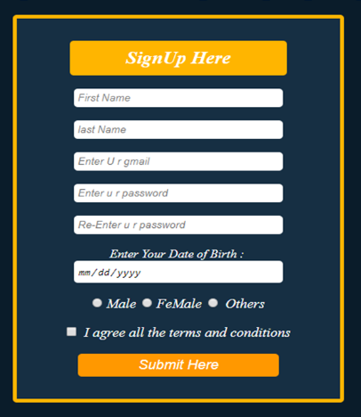

Create the login page shown below. Here User have to enter the Email Address and Password, that will be verified in localStorage. If the emailId and Password are available , then show one message like You are a valid user and the details of that user in that same screen else show error message like not a valid user.

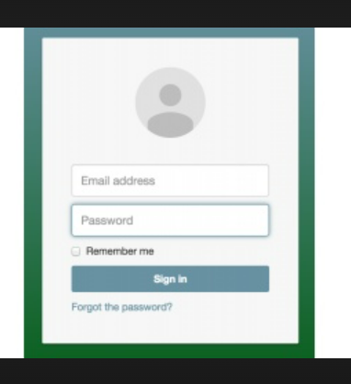

46. Use **Html5 Drag and Drop API** to drag the image from one div and drop in other.

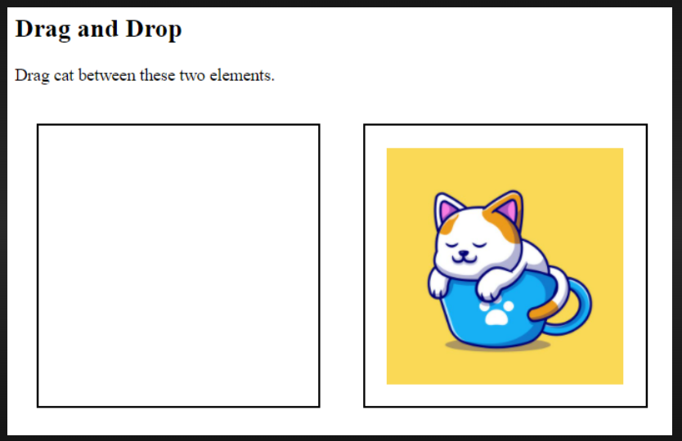

47. Use **HTML5 Geo Location API to display user current location**.

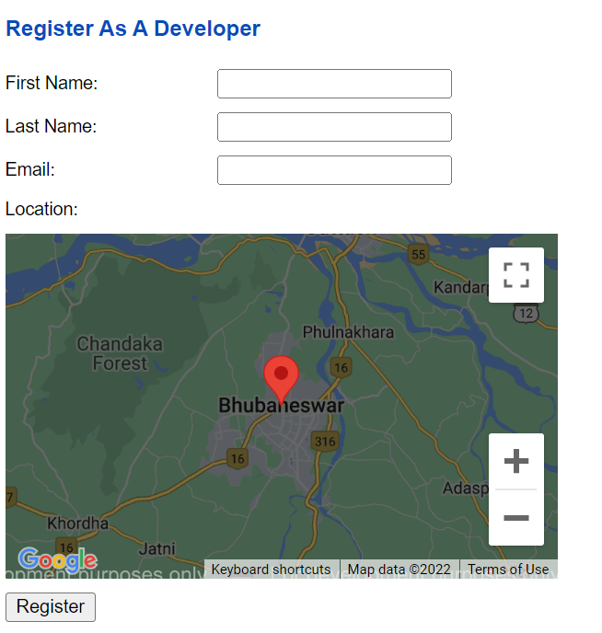

48. Add, subtract ,calculate average of all elements of an array using reduce() method.

const numbers = [175, 50, 25];

Addition: 250

Subtraction: 100

Average: 83.33333333333333

49. Subtract the element of an array using both reduce() and reduceRight() and see the difference.

const numbers = [175, 50, 25];

output: -200

50.

* What is null coalescing operator in JavaScript? Write one example with proper comments.
* What is Optional Chaining Operator. Write one example on your own?
* What is immutability in JavaScript?